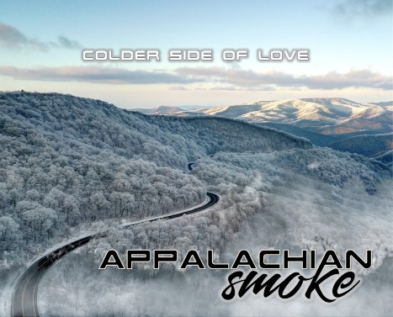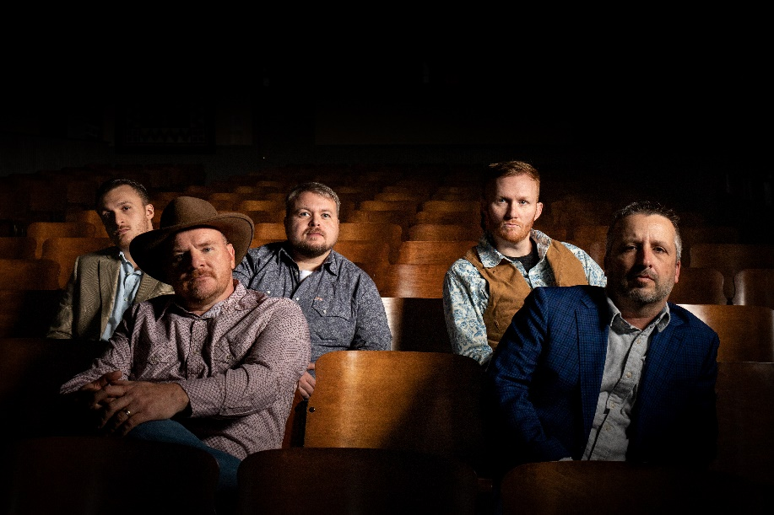

**Booking:**

Bj Taylor

Mikel Laws

Tim Williams

(828) 479-5620

AppalachianSmokeMusic

@gmail.com

**Links**

[**Official Website**](https://www.appalachiansmokemusic.com/)

[**Social Media**](https://www.facebook.com/appalachiansmokemusic)

[**Stream Music**](https://l.facebook.com/l.php?u=https://distrokid.com/hyperfollow/appalachiansmoke/colder-side-of-love?fbclid%3DIwAR34uKTfBVEPTDQGJeJ6cUKx2gWtf1-aXGyWp5pxhEqELH7dYlb8cLqRosQ&h=AT0rQdDwePyOEAVpYqgSK5F9yTMbpUhaab3e7axnktr2hqVclGvFyvJQqFae9Xa7GGBO1agtTxfaUJy46I52uJOI4S4POGtmiYsjFxBHbjk5T6hdNvdwKYTmeW5Eoe8DntrRSWQRL4xCRkCi4A)

[**AirPlay Direct**](https://airplaydirect.com/music/appalachiansmoke/)

[**Press Kit**](https://www.dropbox.com/sh/dmeaoz9dg6s9f19/AAAjdE1ItKv0v66VMTXMNYv5a?dl=0)

**Colder Side of Love** (2022)

Independent Release

*Their all-original debut album, “Colder Side of Love”, was released independently in 2022 and immediately received international airplay. Bluegrass Today’s review of the project applauded, “If the group sticks to this formula, we will be hearing about Appalachian Smoke for a long time to come.”*

*The first track, “Carolina Calling Me”, has been on the Cashbox Top 100 Bluegrass Songs Chart since the fall of 2022, peaking at #2 in December.*

**Whether you are drawn to clever lyrics, dynamic instrumentation, full harmonies, unpredictable arrangements, or an authentic delivery, you’ll find it all in an evening with Appalachian Smoke.**

**“Appalachian Smoke is a relatively new bluegrass group… with a serious sound and some intriguing original material. While the members are still fairly young, they are all experienced players, singers, and songwriters with a nice take on the contemporary bluegrass sound.”**

***- John Lawless, Bluegrass Today***

Appalachian Smoke includes (L-R):

**Mikel Laws-** vocals, banjo, and guitar

**Jamie Mason-** vocals, guitar, and banjo

**Tim Williams-** vocals and bass

**Bj Taylor-** vocals, mandolin, and octave mandolin

**Kenneth Rymer-** vocals and resophonic guitar

**Discography:**